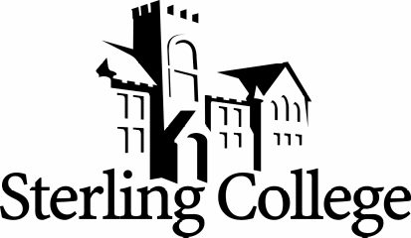

Assistant Athletic Trainer/Approved Clinical Instructor

Position Summary:
The Assistant Athletic Trainer is responsible for the day-to-day operation of the athletic training room, supervision of athletic training students, coverage of athletic practices and competition of sports designated, and complying with all federal and state regulatory agencies in regards to the practice of Athletic Training. The Assistant Athletic Trainer will report to the Director of Athletic Training in performing the following functions.
Athletic training responsibilities will include:
- Reporting to the Director of Athletic Training on matters dealing with the delivery of athletic training services
- Maintaining regular injury and therapeutic intervention records
- Coordinating insurance record keeping of assigned sports
- Conducting regular inventory of supplies and reporting to Director of Athletic Training
- Administering daily treatment and rehabilitation programs for athletes
- Baseline testing of ImPACT
- Assisting the Director of Athletic Training with duties as assigned
Supervision of athletic training students will include:
- Maintaining current BOC recognition as a certified athletic trainer
- Providing direct (physically present) supervision and instruction of students in the Clinical Experience courses within the Athletic Training Educational Program (ATEP)
- Becoming an Approved Clinical Instructor (ACI) of the ATEP and attend all meetings pertaining to the clinical education of the athletic training student
- Following the instruction of the ATEP Program Director/Clinical Education Coordinator in the supervision and evaluation of athletic training students
- Establishing proper communication with students regarding scheduled clinical responsibilities
Coverage of athletic practices and competition will include:
- Primary sport coverage includes: Men’s/Women’s Soccer, Golf, Baseball, Indoor/Outdoor Track & Field
- Providing injury prevention services such as bracing, taping, and application of other protective devices for athletes
- Providing injury and illness evaluation and referral as necessary for athletes
- Providing proper therapeutic interventions following current department/EB practices
- Providing emergency care and referral for athletes
- Coordinating with physicians for appropriate care of injuries and illnesses
- Reporting status of injuries and illness of athletes to coaches
Compliance with federal and state regulatory agencies will include:
- Maintaining BOC certification (50 CEU/two years)
- Maintaining licensure with Kansas State Board of Healing Arts (KSBHA) and follow all regulations for the practice of athletic training (KSBHA Article 69)
- Ensuring that professional behaviors conform to the codes of ethics established by the NATA, BOC and KSBHA

