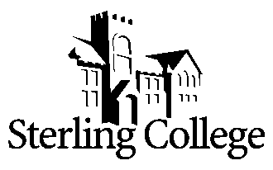
Adjunct Faculty Position for

Theatre Arts - Ballet

POSITION
The Department of Communication, Media & Theatre Arts seeks a part-time adjunct faculty member to teach an undergraduate Ballet course beginning Fall 2022. The department has a strong commitment to undergraduate teaching and part-time faculty are expected to maintain department and college academic standards. If interested, the possibility exists to teach Ballet II in Spring of 2023 or additional dance courses.

RESPONSIBILITIES:
- Teach a beginner's course in Ballet in which students will learn the basic terminology, etiquette, and techniques of ballet. This is an introductory level course and students are not expected to have had previous dance experience.

QUALIFICATIONS
- Master’s degree in dance or a related field, or a bachelor’s in a similar program of study with graduate-level hours in a complimentary field and/or three or more years of professional experience and intent to pursue a master’s degree.
- All faculty members are expected to demonstrate a strong and articulate Christian faith, to model and mentor students in leadership and in the integration of faith into every aspect of life and learning.
- Prior teaching experience.

THE COLLEGE
Founded in 1887, and located in Sterling, Kansas, Sterling College’s mission is to develop creative and thoughtful leaders who understand a maturing Christian faith. With approximately 600 students, of which nearly 40% represent non-majority populations, and 46 full-time faculty members, the campus community shares a vision to serve God's world through training servant leaders and the development of future leaders through strategic partnerships. Learn more about us at www.sterling.edu.

APPLICATION PROCEDURE
A review of applications will begin immediately and continue until the position is filled. The successful candidate must undergo a background check. To view the list of items to be completed to apply for this position, please go to https://www.sterling.edu/employment and view the Adjunct Faculty Position – Ballet job link. Materials are to be submitted electronically to rdodson@sterling.edu.

