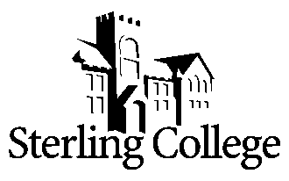
Adjunct Faculty Position for

Language & Literature

POSITION
The Department of Language and Literature seeks a part-time adjunct faculty member to teach undergraduate composition courses beginning Spring 2022. Adjunct faculty will teach LL095 Basic Writing and/or LL101 College Composition I, depending on the needs of the college. The Department of Language and Literature has a strong commitment to undergraduate teaching and part-time faculty are expected to maintain department and college academic standards.

QUALIFICATIONS
- Master’s degree or higher from an accredited institution. At least 18 graduate hours in English literature, rhetoric and composition, or writing.
- All faculty members are expected to demonstrate a strong and articulate Christian faith, to model and mentor students in leadership and in the integration of faith into every aspect of life and learning.
- Prior teaching experience.

THE COLLEGE
Founded in 1887, and located in Sterling, Kansas, Sterling College’s mission is to develop creative and thoughtful leaders who understand a maturing Christian faith. With approximately 600 students, of which nearly 40% represent non-majority populations, and 46 full-time faculty members, the campus community shares a vision to serve God's world through training servant leaders and the development of future leaders through strategic partnerships. Learn more about us at www.sterling.edu.

APPLICATION PROCEDURE
A review of applications will begin immediately and continue until the position is filled. The successful candidate must undergo a background check. To view the list of items to be completed to apply for this position, please go to https://www.sterling.edu/employment and view the Adjunct Faculty Position – Language and Literature job link. Materials are to be submitted electronically to rdodson@sterling.edu.

