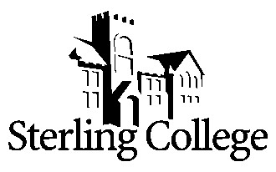

Master of Arts in Sports Ministry
Applicant Questionnaire

Please respond to the following items with no more than one typed page per item.

Our Mission: The purpose of Sterling College is to develop creative and thoughtful leaders who understand a maturing Christian faith.

Our Statement of Faith The board, faculty, administration and staff possess an active and visible Christian faith which encourages the entire campus community in our pursuit of a wholesome and practical Christian life. We personally trust in and collectively bear witness to the one, eternal God, revealed as Father, Son and Holy Spirit.
We believe in God the Father who created the heavens and the earth.

We believe in God the Son, Jesus Christ, who was conceived by the Holy Spirit and born of the Virgin Mary. Jesus suffered, died, and was buried. He rose from the dead. Jesus ascended into heaven and remains with the Father and the Holy Spirit to judge the living and the dead. Jesus Christ alone is the way, the truth and the life. There is salvation in and through no other.
- We believe in God the Holy Spirit who is the comforter, sustainer and sanctifier of all who profess faith in Jesus Christ as Savior and Lord.
- We believe that humanity has hope for redemption from sin by Jesus Christ’s life, death, and resurrection. It is by God’s grace alone that we joyfully receive our salvation through a personal faith in Jesus Christ.
We believe that the Bible is God’s revealed Word. It is authoritative and infallible in all matters of faith and practice.

We believe that the Church is the body of Christ and God’s witness in the world.

We believe that Jesus Christ will return and claim his own, ushering in the new heaven and new earth in which righteousness will dwell and God will reign forever.

- Please describe your personal relationship with Christ and how this finds expression in the local church.

- Please describe how you integrate Christian faith and biblical teaching within your current professional situation.

