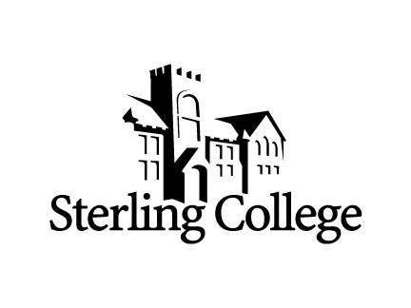

Attention SC classmates from 1968:

Request for you to share your story to be included in the
“Whatever Happened to the Members of the SC Class of 1968” publication.

The reunion planning committee is asking you to send a short biographical sketch of your life and a recent photo of yourself. Even if you cannot attend the reunion we want to have your story. Once we have collected this information we will assemble it into a computer PDF document that we can share with everyone. If you want a printed copy you can just download it.

We are all curious about what everyone from our class did. So, send a short bio of what you’ve done since leaving Sterling College. Email or mail to:

Carolyn (Hanson) Bell
13102 254th Road, Holton, KS 66436-8804
cjhbell@embarqmail.com
(785) 305-1596

Send as soon as possible but no later than September 1. Volunteers will be working on this project and we want to have it ready for the reunion. We will make sure everyone in the class that we have a current email address for will receive this information.

Please limit your information to 500 words and keep it to an 8.5 X 11 sheet of paper. Your story should be about you. Mention your kids and grandkids but do your bragging about them when we are visiting in October. Make sure to include a relatively current photo of yourself.

At the top of your sheet start with this information in this form:
Name (include maiden name where appropriate)
Current mailing address
Email address
Phone number

Thanks for your participation! And we hope to see you October 4-6! Thirteen have already committed to be in Sterling for the reunion!

The 1968 50th Year Reunion Committee

