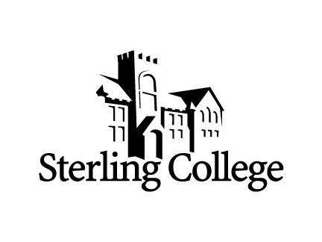

50 Years ago we could barely imagine 2020! It is here!!! We hope it will be possible to continue with plans for a reunion in October in Sterling. MARK YOUR CALENDARS for October 15-18 and participate as you are able. Plans will be released as available and will be posted at the SC website Sterling.edu/reunions as the Homecoming information is developed.

Please share your story to be included in the
“Whatever Happened to the Members of the SC Class of 1970”

Send as soon as possible but no later than September 1.

Include Name (maiden name where appropriate)
Mailing address
Email address
Phone number

Send a short biographical sketch of your life and a recent photo of yourself. Even if you cannot attend the reunion we would enjoy your story. A PDF document will be created to share with everyone.

Send to:

The Bingles OR Peggy McAdoo
322 N Broadway 842 SW Anderson Terr
Sterling KS 67579 Topeka KS 66606
binglenet@gmail.com peggymcadoo@gmail.com
620-204-0315 or 620-204-0204 785-224-5113

Thanks for your participation! Thank you for sharing and please plan to join us in October.

The 1970 50th Year Reunion Committee
Carol and Paul Bingle, Ken Davidson,
Don and Lennette Bonnell, Peggy McAdoo,
& Dave Foster

