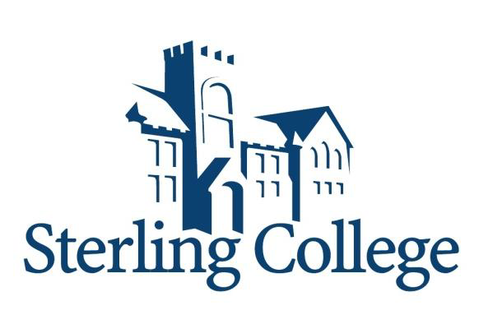

2016-2017
Institutional VerificationWorksheet (DV1)

Your 2016-2017 Free Application for Federal Student Aid (FAFSA) was selected for review in a process called verification. The Department of Education regulations state that before awarding Federal Student Aid, we may ask you to confirm the information you and your parents reported on your FAFSA. To verify that you provided correct information the financial aid administrator will compare your FAFSA with the information on this worksheet and with any other required documents. If there are differences, your FAFSA information may need to be corrected. You and at least one parent must complete and sign
this worksheet, attach any required documents, and submit the form and other required documents to the financial aid office. You may be asked for additional information. If you have questions about verification, contact the financial aid office as soon as possible so that your financial aid will not be delayed.

Section A. Student’s Information

Student’s Last Name First Name M.I. Student’s SSN

Student’s Street Address (include apt. no.) Student’s Date of Birth

City State Zip Code Student’s Email Address

Student’s Home Phone Number (include area code) Student’s Alternate or Cell Phone Number

Section B. Family Information
List the people in your parents’ household. Include:
- yourself and your parent(s) (including stepparent) even if you don’t live with your parents, and
- your parents’ other children even if they don’t live with your parent(s), if (a) your parents will provide more than half of
their support from July 1, 2016, through June 30, 2017 or (b) the children would be required to provide parental information when applying for federal student aid, and
- other people if they now live with your parents, and your parents provide more than half of their support from July 1, 2016
through June 30, 2017.

Number in College: Include below information about any household member, excluding the parents, who will be enrolled at least half time in a degree, diploma, or certificate program at an eligible postsecondary educational institution any time between July 1, 2016 and June 30, 2017, include the name of the college.

Full Name | Age | Relationship | College
 |  | Self | Sterling College

SECTION C. Tax Filer Information
FOR THE STUDENT Please choose ONE of the following.
- Check here if student will not file and are not required to file a 2015 U.S. Income Tax Return*. List total amount earned in 2015 here______________. Please send in a copy of all 2015 W-2 forms if available.
- Check here if student has filed, and had your tax documents imported into FAFSA using the IRS Data Retrieval Tool.
- Check here if student filed an extension and will provide the financial aid office IRS Form 4868 and all W-2 Forms.
- Check here if student provided IRS tax return transcript with verification worksheet. NOTE: Tax transcript may be ordered at www.irs.gov, “Get Transcript by Mail” and fax to 620-869-9033 or mail to 125 W Cooper, Sterling, KS 67579, Attn: Financial Aid. NOTE: Account Transcripts are NOT accepted.

FOR THE PARENT Please choose ONE of the following.

- Check here if parent(s) will not file and are not required to file a 2015 U.S. Income Tax Return*. List total amount earned in 2015 here_____________. Please send in a copy of all 2015 W-2 forms if available.
- Check here if parent(s) has filed, and had their tax documents imported into FAFSA using the IRS Data Retrieval Tool.
- Check here if parent(s) filed an extension and will provide the financial aid office IRS Form 4868 and all W-2 Forms.
- Check here if parent(s) provided IRS tax return transcript with verification worksheet. NOTE: Tax transcript may be ordered at www.irs.gov, “Get Transcript by Mail” and fax to 620-869-9033 or mail to 125 W Cooper, Sterling, KS 67579, Attn: Financial Aid. NOTE: Account Transcripts are NOT accepted.

*Tax returns include the Federal 2015 IRS Form 1040, 1040A, 1040EZ, a tax return from Puerto Rico or a foreign income tax return.

SECTION D. Food Stamps—Supplemental Nutrition Assistance Program (SNAP)
Please confirm the following for anyone who is living in your household. Please choose ONE of the following.

- My parent or a member of the household, received benefits from the Supplemental Nutrition Assistance Program or
SNAP (formerly known as food stamps) any time during the 2014 or 2015 calendar year. Name of Recipient _________________________________
- My parents or a member of the household, DID NOT receive SNAP benefits during the 2014 or 2015 calendar year.

SECTION E. Child Support Paid

Please confirm the following for anyone who is living in your household. Please choose ONE of the following.

- The student or parent(s) paid child support during the 2015 calendar year (Complete the chart below).
- The student or parent(s) DID NOT pay child support during the 2015 calendar year (Skip to Section F).

Name of Person Who  Paid Child Support | Name of Person to Whom Child Support was Paid | Name of Child for Whom  Child Support was Paid | Amount of Child Support  Paid in 2015

WARNING: If you purposely give false or misleading information to help establish eligibility for federal student aid, you may be subject to a $20,000 fine, a prison sentence, or both.

VERIFICATION CAN NOT BE COMPLETED WITHOUT ALL REQUIRED DOCUMENTS.

SECTION F. SIGNATURES

By signing this worksheet, I (we) certify that all the information reported to qualify for federal student aid is complete and correct. At least one parent must sign.

Student Date Parent Date

You should make a copy of this worksheet for your records.

Return to: Sterling College
Attn: Financial Aid
125 W. Cooper, Sterling, KS 67579
Phone: (620) 278-4407 Fax (620) 869-9033
Revised 01/2016

