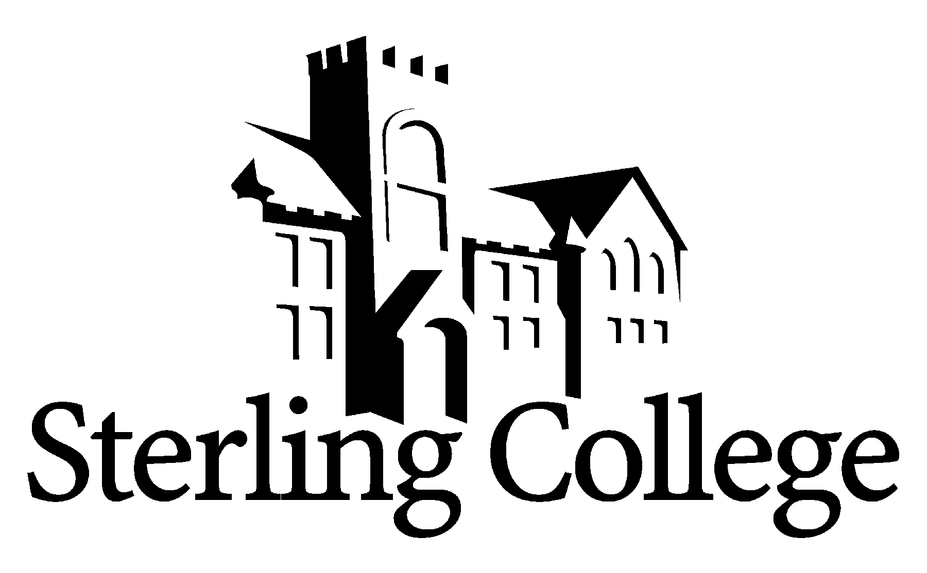
Faculty Position Announcement

Language and Literature

POSITION
A full-time faculty position in the Language and Literature Department is available beginning August 1, 2020.

- Teach courses in freshman composition, literature, and writing and editing.
- Assume primary responsibility for overseeing the equipping of college freshmen with the writing skills needed for successful completion of bachelor’s degree.
- Assist the faculty and the Director of Academic Support in addressing the writing needs of students.
- Assist in maintaining and revising the English program and Writing and Editing program curricula as needed.
- Advise students and recruit prospective students.
- Participate in faculty committees as needed.

QUALIFICATIONS
All SC employees are expected to demonstrate a strong and articulate Christian faith, to model and mentor students in servant leadership and in the integration of faith into every aspect of life and learning. Specific requirements for this position include:
- Ph.D. or M.F.A. preferred.
- College teaching experience that demonstrates an understanding of the teaching/learning process preferred.
- An understanding of undergraduate college students and an ability to relate well to them.
- An understanding of an interdisciplinary approach to the liberal arts, and an ability to work with faculty from diverse disciplines.

COMPENSATION
Salary and rank will be determined by credentials and experience. The College provides a benefits package and stipend for moving expenses.

THE COLLEGE
Founded in 1887, Sterling College’s mission is to develop creative and thoughtful leaders who understand a maturing Christian faith. The campus community shares a vision to be recognized as the finest Christ-centered, servant-leadership-development-focused liberal arts experience in the Great Plains. Located in Sterling, Kansas, the College enjoys a cordial relationship with this city of 2,600. Hutchinson (pop. 40,000) is a 25-minute drive, and Wichita (pop. 300,000) is about 65 minutes away. Learn more about us at www.sterling.edu.

APPLICATION PROCEDURE
A review of applications will begin immediately and continue until the position is filled. Women and minorities are encouraged to apply. The successful candidate must undergo a background check. To view the list of items to be completed to apply for this position, please go to https://www.sterling.edu/employment and view the Language and Literature job link. Materials are to be submitted electronically to rdodson@sterling.edu.

