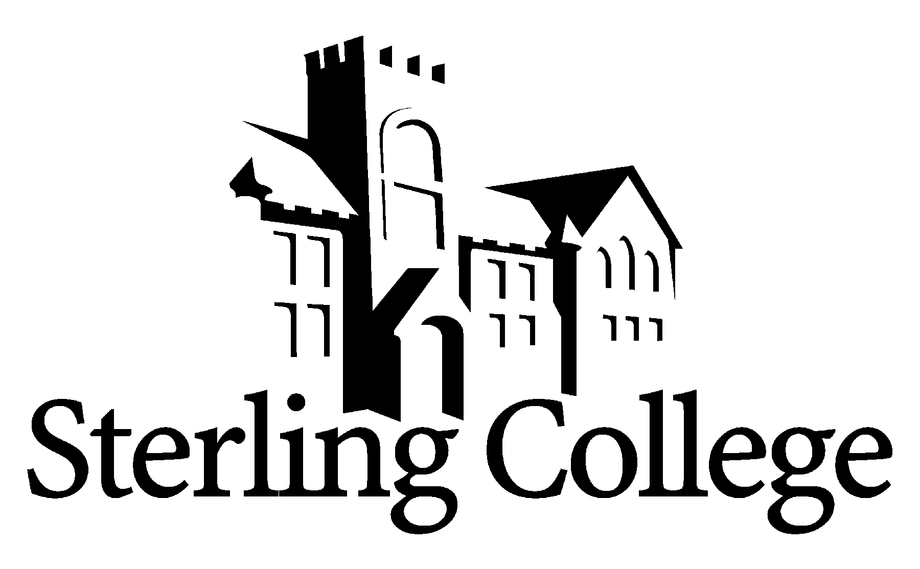
Faculty Position Announcement
Assistant Professor: Media & Communication

POSITION
A full-time faculty position serving in the Department of Communication, Media & Theatre Arts is available beginning January 2026. We are seeking a broadly skilled individual, who is energetic about holding high standards and assisting students in developing high-caliber work.

RESPONSIBILITIES
- Teach a variety of courses in the Department of Communication, Media & Theatre Arts. Courses may include courses covering film studies, broadcast journalism, web design & production, sports communication & media, mass media writing and media law and ethics.
- Envision and promote program expansion and development including assisting with recruiting efforts.
- Advise current students.
- Assist the Sterling College Teacher Education and theatre/communication faculty to maintain Kansas State Board of Education.

QUALIFICATIONS
All SC employees are expected to demonstrate a strong and articulate Christian faith, to model and mentor students in servant leadership and in the integration of faith into life and learning. Specific requirements for this position include:
- M.A. or M.S. required in media studies, broadcasting, journalism or other related fields. Specific area of degree is not as important as skills, portfolio, and references revealing an excellence of instruction.
- Experience in areas such as media production, podcasting/radio will be advantageous to the candidate.
- Strong collaborative skills and leadership ability.
- An understanding of an interdisciplinary approach to the liberal arts, and an ability to work with
faculty from diverse disciplines.
- College teaching experience that demonstrates an understanding of the teaching/learning process preferred.

COMPENSATION
Salary and rank will be determined by credentials and experience. The College also provides a benefits package and a stipend for moving expenses.

THE COLLEGE
Founded in 1887, and located in Sterling, Kansas, Sterling College’s mission is to develop creative and thoughtful leaders who understand a maturing Christian faith. With approximately 600 students, of which nearly 40% represent non-majority populations, and 48 full-time faculty members, the campus community shares a vision to serve God's world through training servant leaders and the development of future leaders through strategic partnerships. Learn more about us at www.sterling.edu.

APPLICATION PROCEDURE
A review of applications will begin immediately and continue until the position is filled. Women and minorities are encouraged to apply. The successful candidate must undergo a background check. To view the list of items to be completed to apply for this position, please go to https://www.sterling.edu/employment. Materials are to be submitted electronically to rdodson@sterling.edu.

In addition to the online application, candidates are encouraged to submit a portfolio of items of their personal work in journalism, web design, edited clips, new-media work or other applicable works. Candidates are strongly encouraged to submit examples of student work created under their instruction.

Portfolios of still images, video or audio reels or other media may be submitted as a URL/link, a downloadable link. Attachments should be less than 15MB in total if emailed.

