|  |
| --- |
|  |
| OPT Application Packet |
| Name: ____________________ SC ID# ___________________ |
| * Appointment with Student to review all forms * OPT Request form received * Reporting Acknowledgement Form received * Letter of Recommendation from Advisor received * Applicant letter requesting OPT received * Endorse Form I-20 and make notation in SEVIS * Copies of **ALL** I-20s for the applicant * I-765 complete and signed * G-1145 signed * Money order received * Passport photos received * Scan copy of all paperwork to keep in file and email to student * *Report OPT Participation in SEVIS(after approval)* * *Photocopy of EAD received an put in permanent file*   ***\*While student are on authorized OPT they are to be considered F-1 students of the institution. As such, accurate addresses and emergency contacts must be kept on file while they are in the United States.*** |
|  |
|  |

|  |
| --- |
| Optional Practical Training application packet for F-1 students. All information must be completed and submitted, reviewed by DSO and entered appropriately into SEVIS |



**F-1: OPTIONAL PRACTICAL TRAINING (OPT)**

GENERAL INFORMATION:

OPT provides practical experience in an F-1 student’s major area of study, complementary to the academic program. This type of training is available to students who have been enrolled on a full-time basis for at least one academic year. An F-1 student is eligible for a MAXIMUM OF 12 MONTHS. However, if a student begins a new academic program at a higher level, the student is eligible to apply for another 12 months of OPT. A foreign student in F-1 nonimmigrant status participating in OPT must receive Form I-766, employment Authorization Document (EAD) from USCIS before he or she is authorized to work. He or she may not begin OPT until the date indicated on the EAD.

OPT is available in the following cases:

1. Part-time or full-time work during the student’s annual vacation and at other times when school is not in session, as long as the student intends to register for the next term of the session. (Pre-Completion)
2. For up to 20 hours per week while school is in session
3. Full time work after completion of the course of study (Post-Completion). After finishing a course of study, a student must complete all practical training within a 14-month period. Some foreign students may be eligible for a one time, 17-month extension of their OPT, if they received their degree in science, technology, engineering or mathematics (STEM).

It takes USCIS approximately three months to process applications for OPT. For options 1 and 2, students can apply as early as 90 days before their intended start date for OPT. Students applying for Post-Completion OPT **must complete and send their application to USCIS before they complete their degree program,** and can apply 90 days prior to program end date and up to 60 days after the program end date, provided that it is *filed with the USCIS* within 30 days of the date the DSO enters the OPT recommendation into SEVIS.

While on OPT, individuals are still considered to be F-1 students at Sterling College, even though they may be working elsewhere in the United States. If there happen to be any changes of personal information such as name, address, employer’s information or periods of unemployement, this **must be reported to Sterling College within 10 days of the change.** Students on Post-Completion OPT cannot have more than 90 days of cumulative unemployment.

Students wanting to travel outside of the United States, while on OPT, **must** obtain a travel signature from the DSO at Sterling college on their I-20 within the last six months in order to re-enter into the U.S. It is recommended that you consult with your DSO before planning any trips.

**STEP 1**:

APPLICATION PROCESS:

Make an appointment with the DSO to initiate a request and bring the following information:

1. Completed Form I-765
2. Completed Form G-1145
3. All previous Form I-20(s)
4. Passport
5. Form I-94
6. Completed OPT Request Form (Page 7)
7. OPT Reporting Acknowledgement Form (Page 5)

*After reviewing the material listed above the DSO will recommend the OPT by endorsing Form I-20 and by making the appropriate notation in SEVIS, the system used to track F-1 academic students.*

**STEP 2**:

Students may not legally work until an Employment Authorization Document has been issued by USCIS. The student must send the following documents to the lockbox for approval and wait for issuance of the EAD.

1. Completed Form I-765
2. Completed Form G-1145
3. Letter requesting OPT from applicant
4. Letter of recommendation from Academic Advisor
5. Check or money order in the amount of $380, payable to the Department of Homeland Security (Must be drawn at a financial institution that is physically located in the United States).
6. Photocopies of all Form 1-20s, including the OPT I-20 with the OPT Recommendation Form.
7. Photocopy of Form I-94 (front and back)
8. Photocopy of passport and visa (**must** include a clear copy of photo page and page of expiration). If you are Canadian you may enclose a copy of your citizenship card, or a birth certificate and a government issued photo ID.
9. 2 U.S. passport-style photos as follows:
10. Photos must have been taken within the last **30 days**.
11. Full face, front view, eyes open
12. Make sure photo presents full head from top of hair to bottom of chin.
13. Height of head should measure 1 inch to 1 3/8 inches
14. Center head within frame
15. Make sure eye height is between 1 1/8 inches to 1 3/8 inches from bottom of photo
16. Photo should be against a plain white or off white background and there should be no distracting shadows on the face or background.
17. Lightly print your name on the back of each photo with a pencil.

**Step 3:**

Mail the completed documents from Step 2 by certified mail to one of the lockbox addresses. *DO NOT WAIT TO MAIL YOUR APPLICATION AS IT MUST BE RECEIVED BY USCIS WITHIN 30 DAYS OF THE ISSUANCE OF THE OPT I-20.*

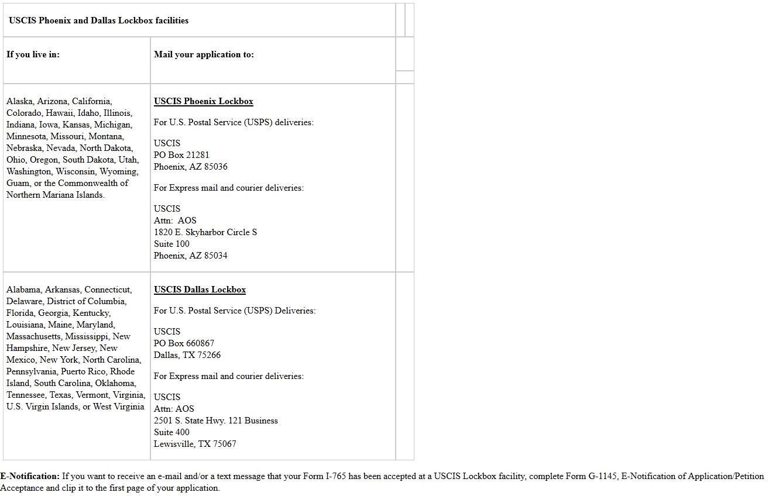

**STEP 4:**

If you decide for some reason **not** to mail the application and documentation, please advise Sterling College immediately as we will need to cancel out your OPT recommendation in SEVIS as well. If you fail to do this, there may end up being long term negative effects.

**STEP 5: VERY IMPORTANT**

AFTER RECEIVING YOUR EAD:

Submit a photocopy of your Employment Authorization Document (EAD) to Sterling College. USCIS requires that a copy be kept in your permanent file. You may send it in the following ways:

fax (620)278-4412,

email: [registrar@sterling.edu](mailto:registrar@sterling.edu),

mail: 125 W. Cooper, Sterling KS 67579,

**STEP 6:**

You have signed the OPT Reporting Acknowledgment Form, at the time of the OPT application process. You have acknowledged your responsibility to report any changes in personal or employment information. Please remember that you are required to report these updates within 10 days of any changes. You may do so by sending the information in the same above manner.



**OPT STATUS ACKNOWLEDGEMENT FORM**

The Department of Homeland Security (DHS) requires F-1 students on Optional Practical Training (OPT) to report to the Office of International Students and Scholars the following:

● Address and name change within 10 days of the change; (Form AR-11)

● Any periods of interruption in your employment including any and all changes in employer(s);

● Name and address of employer (including when you change employers.

**Please review the following regulations:**

* 8 CFR 214.2(f)(5) defines the duration of status for F-1 students as “the time during which an F-1 student is pursuing a full course of study at an educational institution approved by the Service for attendance by foreign students, or engaging in authorized practical training following completion of studies …”

* 8 CFR 214.2(f)(17) requires that “A student must inform the DSO and the Service of any legal changes to his or her name or of any change of address, within 10 days of the change, in a manner prescribed by the school. A student enrolled at a SEVIS school can satisfy the requirement in 8 CFR 265.1 of notifying the Service by providing a notice of a change of address within 10 days to the DSO, who in turn shall enter the information in SEVIS within 21 days of notification by the student.”

* 8 CFR 214.2(f)(12) requires that “An F-1 student authorized by the Service to engage in practical training is required to report any change of name or address, or interruption of such employment to the DSO for the duration of the authorized training.

* 8 CFR 214.3(g)(3) requires reporting within 21 days of change in “Any other notification request made by SEVIS with respect to the current status of the student”.

***I acknowledge that I am responsible for reporting the above mentioned DHS requirements to Sterling College as specified in the regulations.***

**I also acknowledge that in case I have to depart the U.S. during my valid OPT, and will not return, I need to complete and submit the Notification of Department/Withdrawal/Completion form and email it to** [**registrar@sterling.edu**](mailto:registrar@sterling.edu) **or fax to (620) 278-4412. By acknowledging that I will not be returning to the U.S. my SEVIS record will be terminated and my OPT (Employment Authorization Document) will be cancelled. I understand that I will need to request a new I-20 should I decide to return to the U.S. to attend Sterling College.**

_______________________________ _____________________________ __________________

Print Name Signature Date



**NOTIFICATION OF DEPARTURE/COMPLETION OF PROGRAM/EARLY GRADUATION/WITHDRAWAL**

Name: ____________________________________________ Date of Birth: ____________

Foreign Address: _________________________________ SC ID #: ______________

_________________________________ SEVIS ID# ______________

_________________________________

Phone Number: _________________________________ Citizenship: ____________

Email: _________________________________ Birth Country: ___________

Immigration Status: ____________________

Departure Date: ____________________

**Please read the following information CAREFULLY and check the box that applies to you:**

* I must leave the U.S. immediately due to ________________________________. I understand that my current SEVIS record will be terminated, and I will need to contact Sterling College for a new I-20 if/when I am ready to return.
* I certify that I must depart the U.S. immediately and will return to Sterling College within 5 months. I plan to register for the _______________ 20______ semester and ask that my SEVIS record be maintained. **(I understand that I cannot use this option for the Fall semester if I was not enrolled during the Spring semester)**
* I certify that I have completed my degree program at Sterling College and will not apply for post-completion OPT; and will be returning to my home country. Therefore I authorize Sterling College to complete my program in SEVIS
* I certify that I have applied for OPT and received my EAD card but will not be using the card to work in the U.S.; and will be returning to my home country. Therefore I authorize Sterling College to complete my program in SEVIS.
* I certify that I will be graduating earlier that the program completion date on my I-20. My new graduation date will be _______________________.

**To be completed by the Registrar for this last option only:**

**Signature: _______________________________________ Date: ___________________________**

**Student Signature: _________________________________ Date:______________________**

FOR OFFICE USE ONLY: Date of Receipt: ______________________

I-20 Program Start Date: _______________ I-20 End Date: ______________________

Date SEVIS Record Terminated: ________________________ By: _________________________



PART A: TO BE COMPLETED BY STUDENT:

**OPTIONAL PRACTICAL TRAINING (OPT) I-20 REQUEST FORM**

OPT for F-1 students is intended to provide hand-on practical work experience. An F-1 student is eligible for a maximum of 12 months of OPT. It is available to students who have been lawfully enrolled on a full-time basis for one academic year. The practical training sought by the student **must be directly related to his or her field of study and recommended by their academic advisor.**

|  |  |
| --- | --- |
| Date: | SC ID# |
| Name: | Email: |
| Home Phone #: | Cell Phone #: |
| Type of OPT:   * Post Completion OPT (Working after completed Degree * Pre-Completion OPT (Not commonly used) | OPT Requested Start Date: (mm/dd/yyyy) |
| **By signing, I authorize Sterling College to open my mail coming from United States Citizenship and Immigration Services (USCIS in reference to my OPT application** | OPT Requested End Date: (mm/dd/yyyy) |
| Signature: | \***if Dates are Blank, your request will be processed for 12 months of post-completion OPT.** |
| List any previously authorized employment for practical training: | Dates: (Start and End) and Type (OPT or CPT) |

PART B: TO BE COMPLETED BY ACADEMIC ADVISOR AND REGISTRAR:

Major: _________________________

Credits Remaining Until Graduation: ___________ Expected Date of Completion: ___________

Registrar’s Signature: ______________________________________ Date: _______________

I recommend this student for Optional Practical Training:

Academic Advisor Signature: ________________________________ Date: _______________